**SQL Lesson 1: SELECT queries 101**

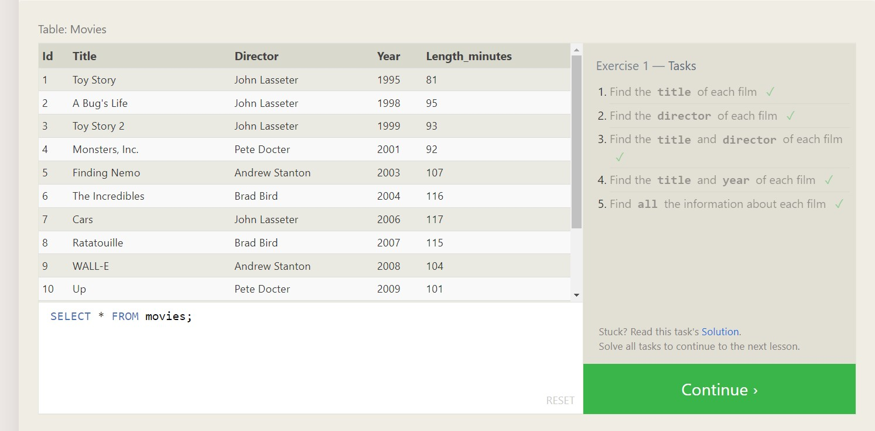

1.SELECT title FROM movies;

2.SELECT director FROM movies;

3.SELECT title, director FROM movies;

4.SELECT title, year FROM movies;

5. SELECT * FROM movies;

**SQL Lesson 2: Queries with constraints(pt.1)**

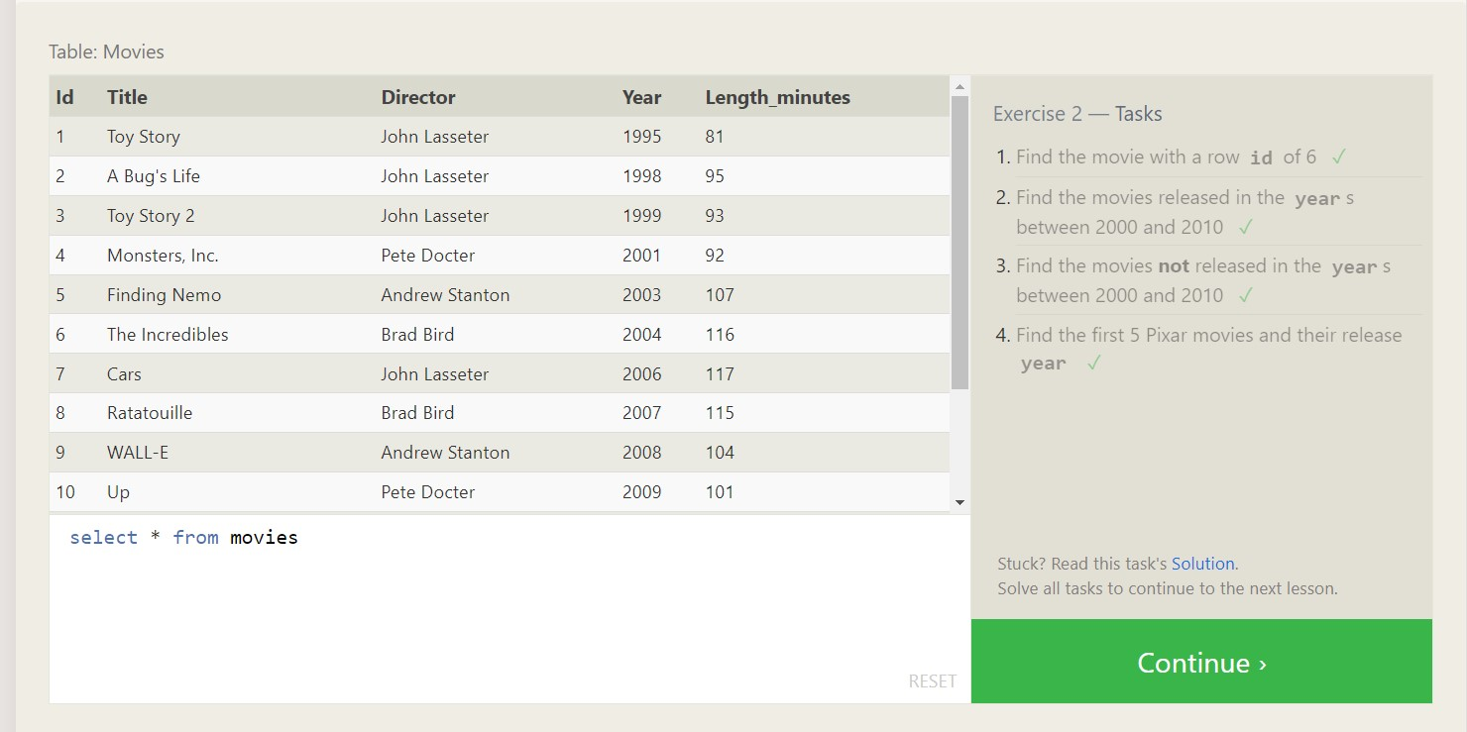

1.SELECT id, title FROM movies

Where id=6;

2.SELECT title, year FROM movies

Where year between 2000 and 2010;

3.select title, year from movies

Where year not between 2000 and 2010;

4. select title, year from movies

Where year <=2003;

**SQL Lesson 3: Queries with constraints (Pt. 2)**

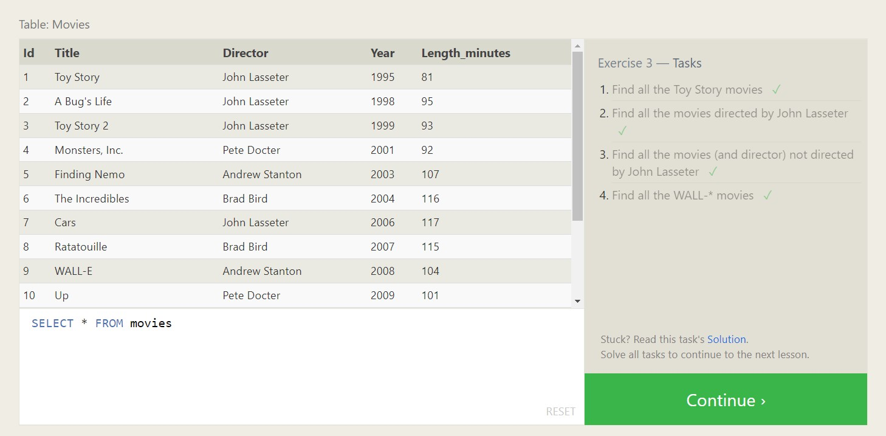

1.select title, director from movies

Where title like “toy story%”;

2. select title, director from movies

where director like "john lasseter";

3. select title, director from movies

where director !="john lasseter";

4. select * from movies

Where title like “wall-_”;

**SQL Lesson 4: Filtering and sorting Query results**

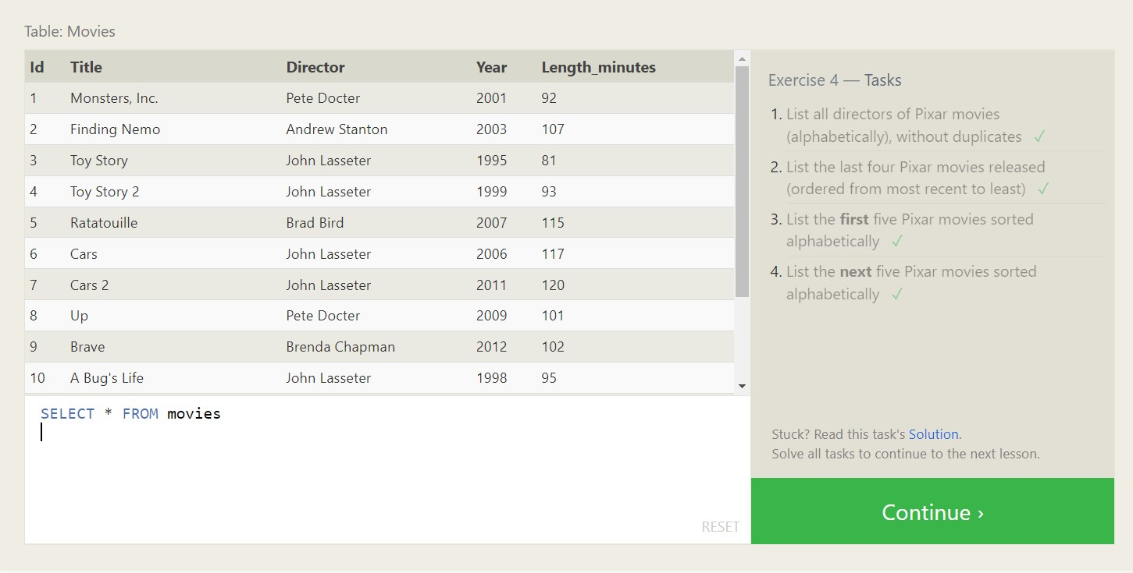

1.select distinct director from movies

Order by director asc;

2.select title, year from movies

Order by year desc

Limit 4;

3. select title from movies

order by title asc

limit 5;

4.select title from movies

order by title asc

limit 5 offset 5;

**SQL Review: Simple SELECT Queries**

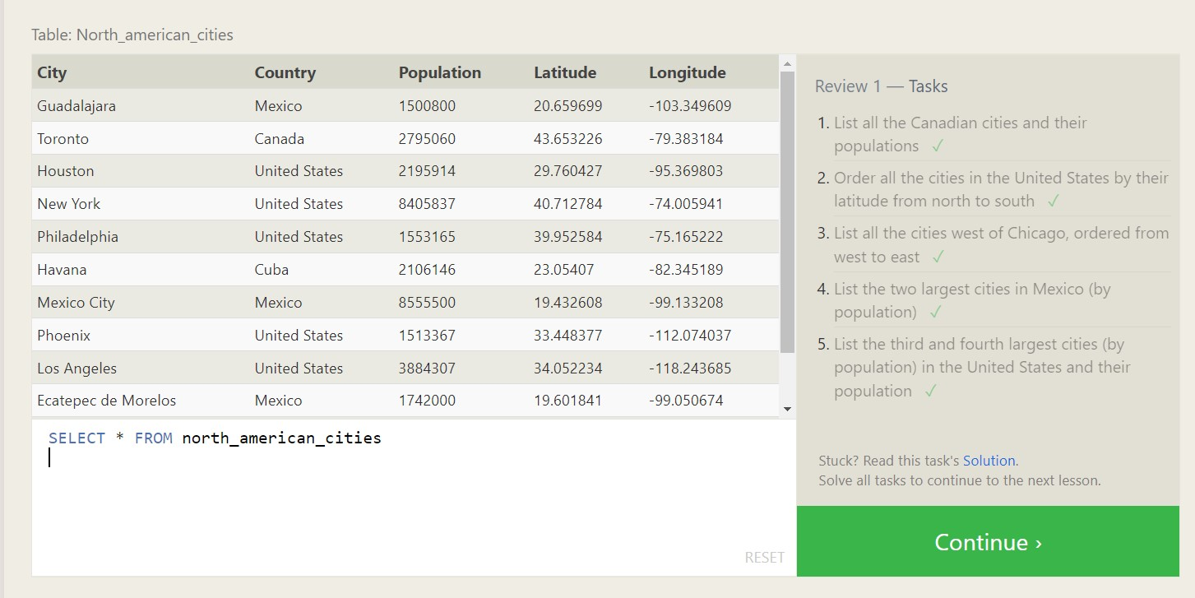

1.select city, population from north_american_cities

where country=”Canada”;

2. select city, latitude from north_american_cities

where country=”united states”

order by latitude desc;

3. select city, longitude from north_american_cities

where longitude<-87.629798

order by longitude asc;

4.select city, population from north_american_cities

where country like “Mexico”

order by population desc

limit 2;

5. select city, population from north_american_cities

where country like “united states”

order by population desc

limit 2 offset 2;

**SQL Lesson 6: Multi-table queries with JOINs**

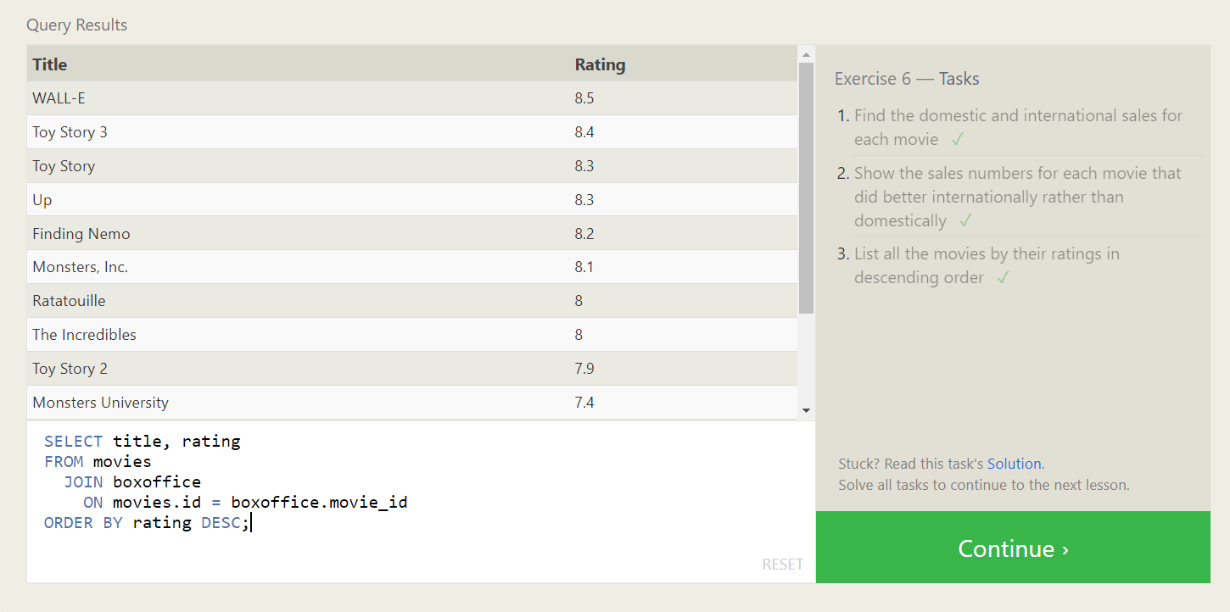

1.select title, domestic_sales, international_sales

from movies

join boxoffice

on movies.id=boxoffice.movie_id;

2. select title, domestic_sales, international_sales

from movies

join boxoffice

on movies.id=boxoffice.movie_id

where international_sales>domestic_sales;

3.select title, rating

from movies

join boxoffice

on movies.id=boxoffice.movie_id

order by rating desc;

**SQL Lesson 7: OUTER JOINs**

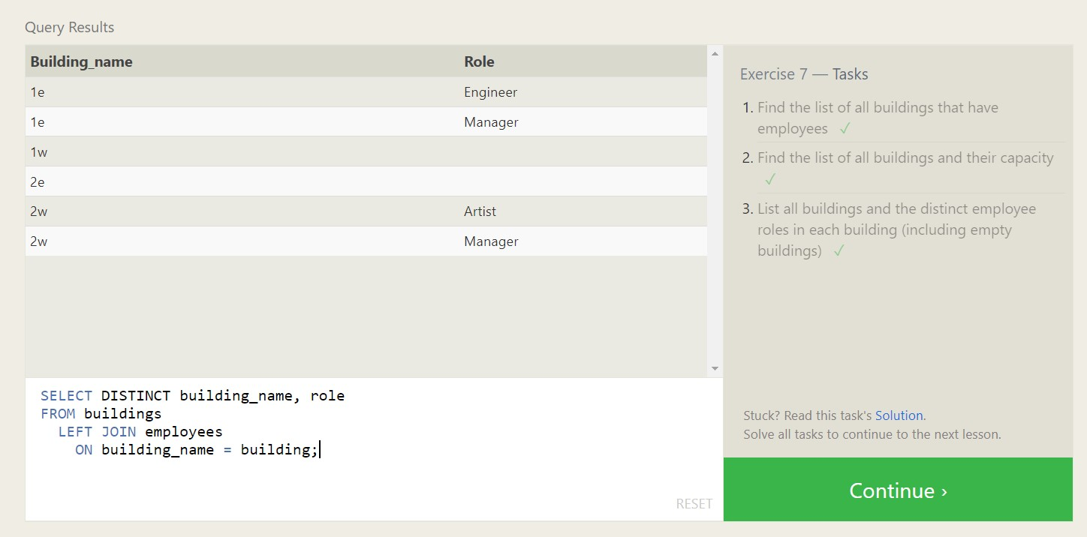

1.select distinct building from employees;

2.select * from buildings;

3.select distinct building_name, role

From buildings

Left join employees

On building_name=building;

**SQL Lesson 8: A short note on NULLs**

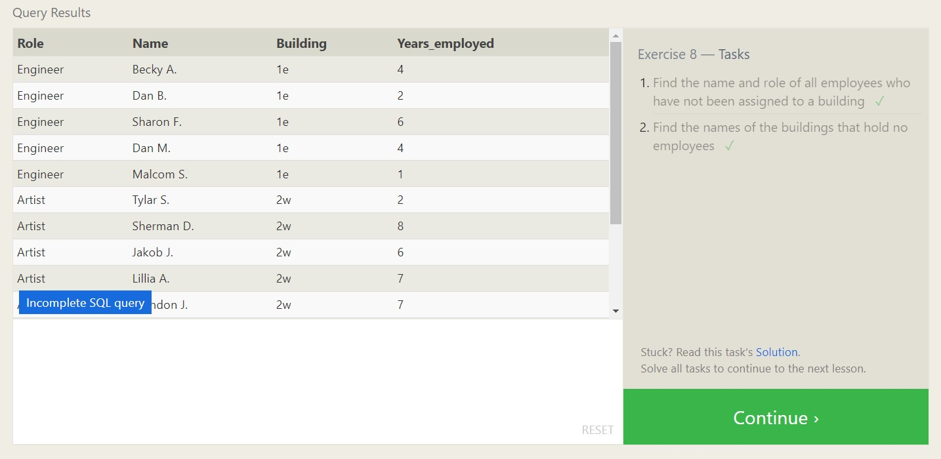1.select name, role from employees

Where building is null;

2.select distinct building_name

From buldings

Left join employees

On building_name = building

Where role is null;

**SQL Lesson 9: Queries with expressions**

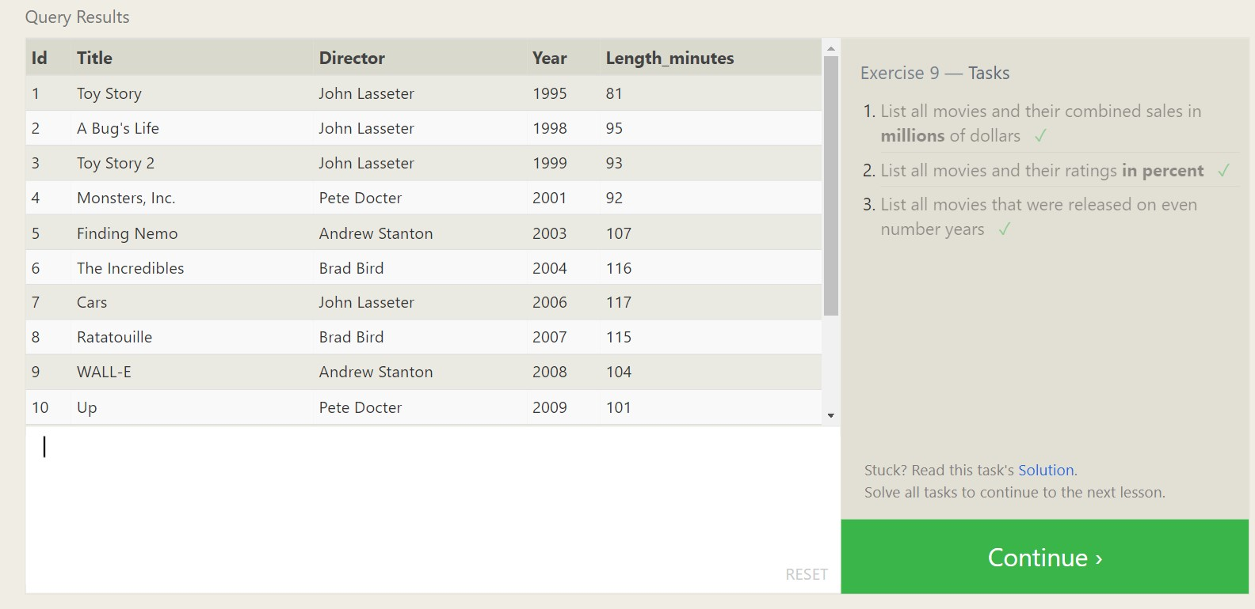

1. select title, (domestic_sales + international_sales) / 1000000 AS gross_sales_millions

from movies

join boxoffice

on movies.id = boxoffice.movie_id;

2. select title, rating * 10 AS rating_percent

From movies

Join boxoffice

On movies.id = boxoffice.movie_id;

3. select title, year

From movies

Where year % 2=0;

**SQL Lesson 10: Queries with aggregates (Pt.1)**

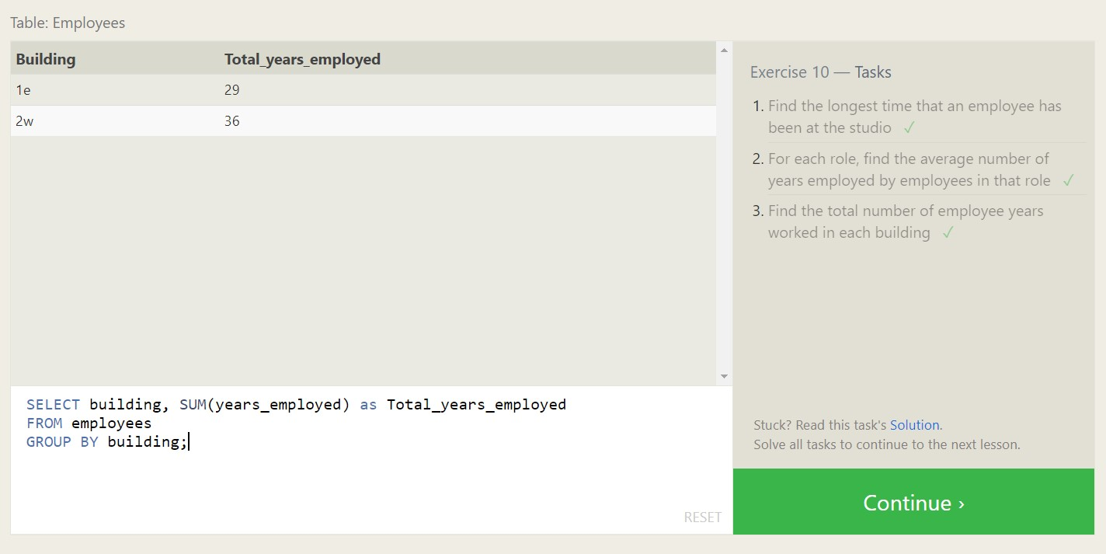

1. Select max(years_employed) as max_years_employed

From employees;

2. select role, AVG(years_employed) as Average_years_employed

From employees

Group by role;

3. select building, SUM(years_employed) as Total_years_employed

From employees

Group by building;

**SQL Lesson 11: Queries with aggregates (Pt. 2)**

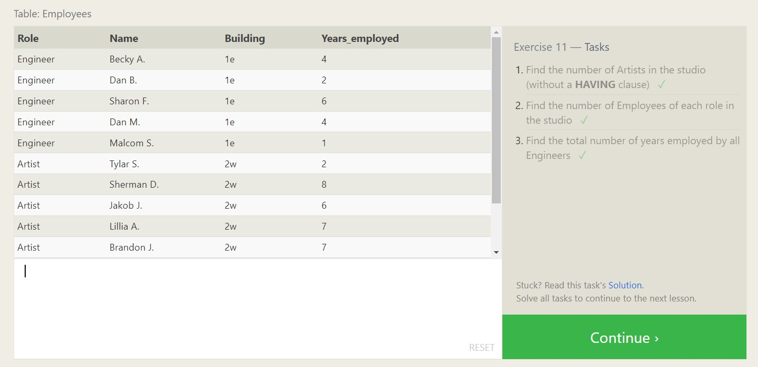

1. select role, count(*) as Number_of_artists

From employees

Where role = "Artist";

2.select role, count(*)

From employees

Group by role;

3.select role, SUM(years_employed)

From employees

Group by role

Having role = "Engineer";

**SQL Lesson 12: Order of execution of a Query**

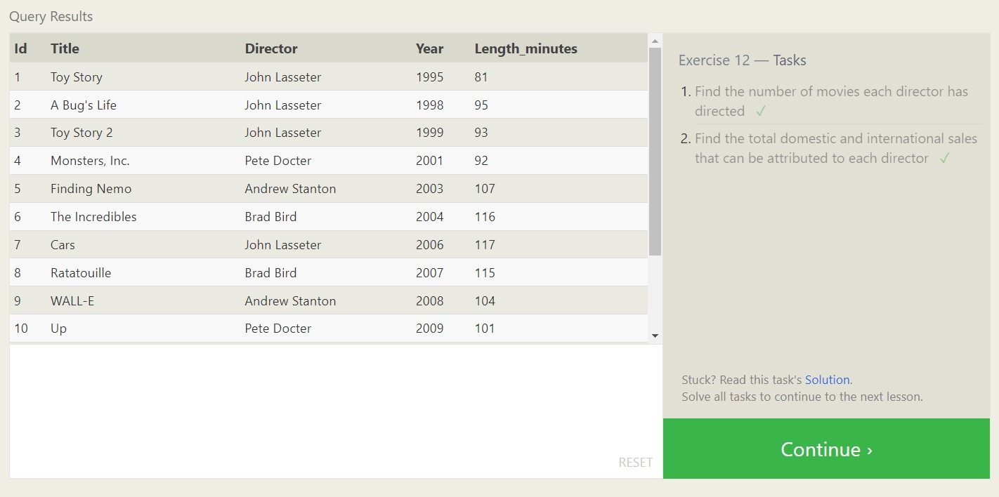

1. select director,count (id) as Num_movies_directed

From movies

Group by director;

2. select director, sum(domestic_sales + international_sales) as Cumulative_sales_from_all_movies

From movies

Inner join boxoffice

On movies.id = boxoffice.movie_id

Group by director;

**SQL Lesson 13: Inserting rows**

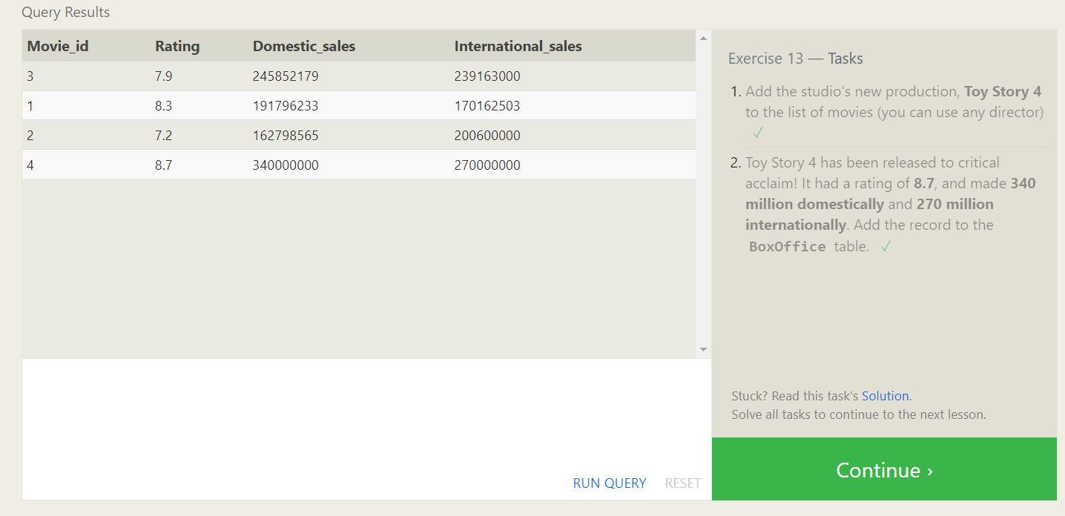

1. insert into movies values (4, "Toy Story 4", "El Directore", 2015, 90);
2. insert into boxoffice values(4, 8.7, 340000000, 270000000);

**SQL Lesson 14: Updating rows**

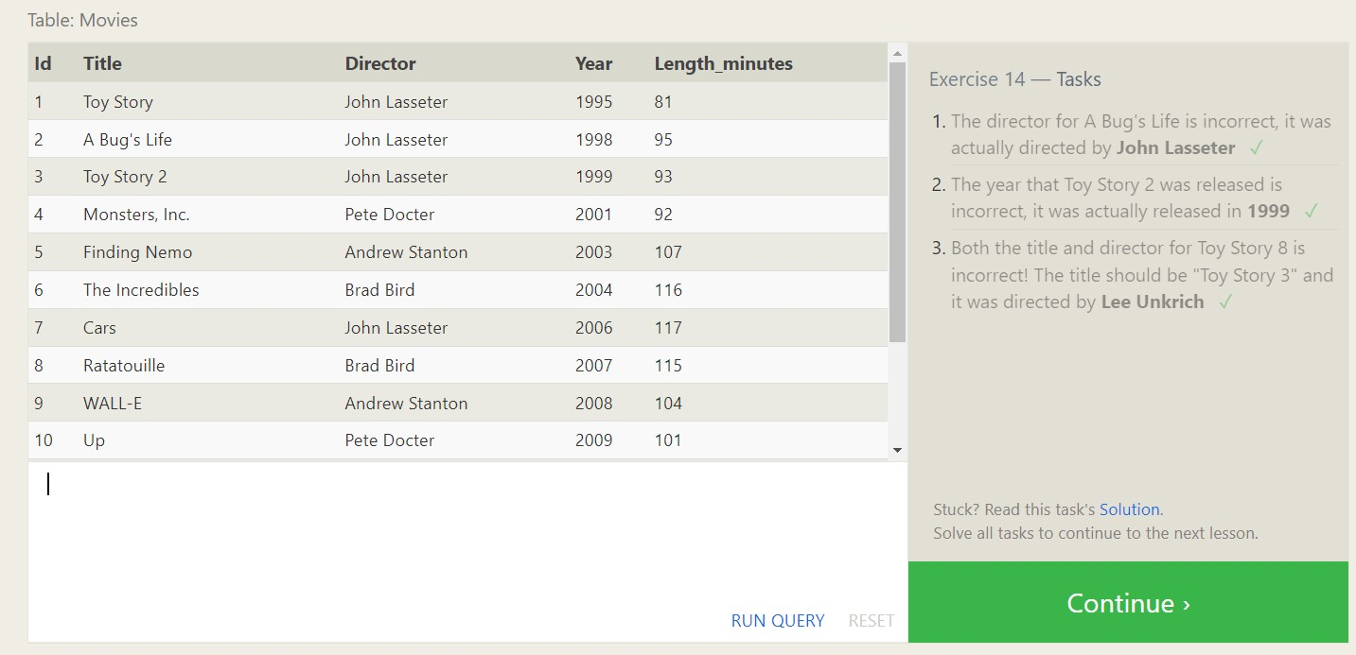

1. update movies

Set director = "John Lasseter"

Where id = 2;

2. update movies

Set year = 1999

Where id = 3;

3. update movies

Set title = "Toy Story 3", director = "Lee Unkrich"

Where id = 11;

**SQL Lesson 15: Deleting rows**

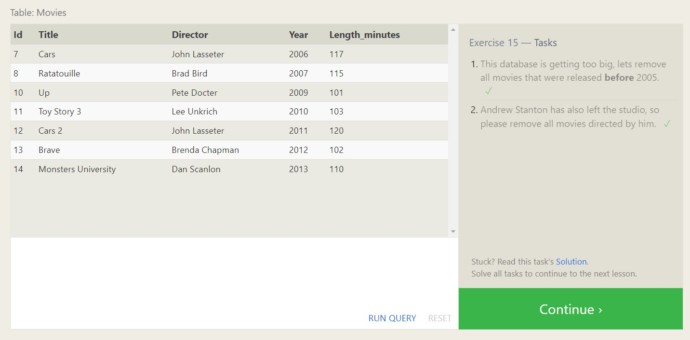

1. delete from movies

where year < 2005;

2. delete from movies

where director = "Andrew Stanton";

**SQL Lesson 16: Creating tables**

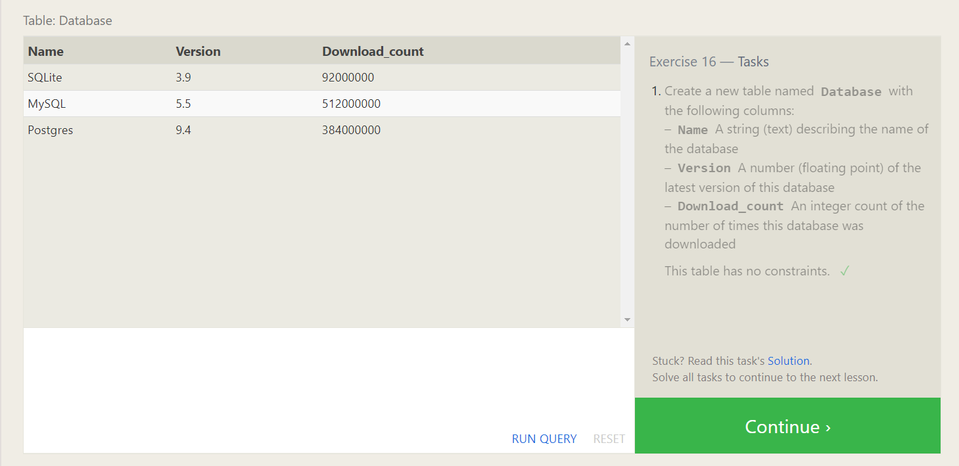

1. create table Database (

Name text,

Version float,

Download_count integer

);

**SQL Lesson 17: Altering tables**

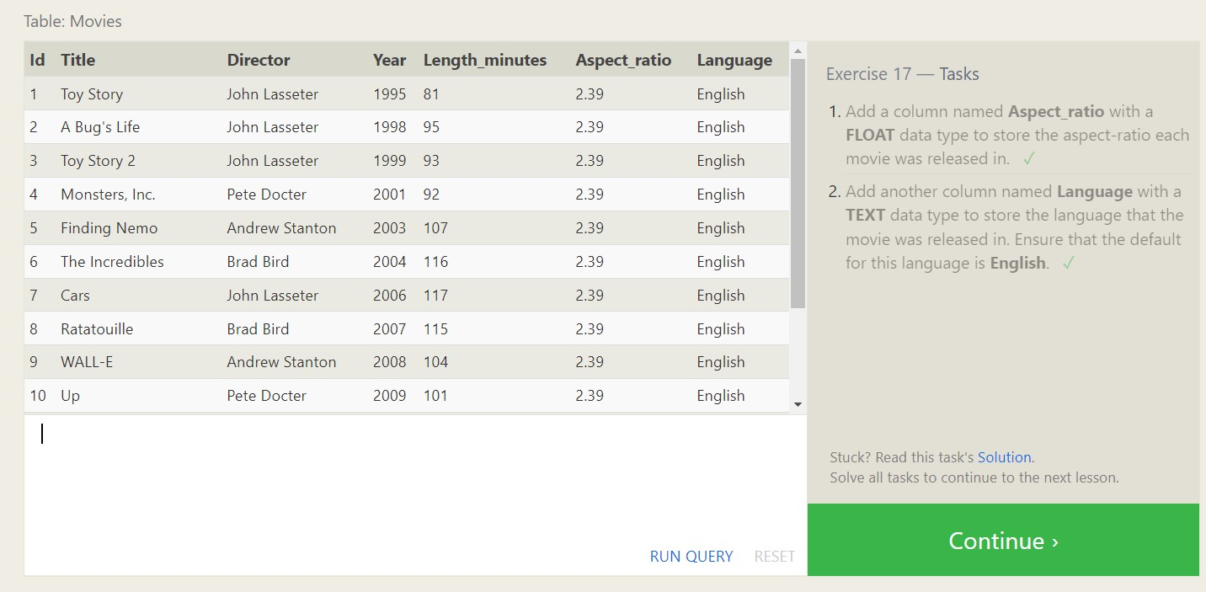

1. alter table Movies

Add column Aspect_ratio float default 2.39;

2. alter table Movies

Add column Language text default "English";

**SQL Lesson 18: Dropping tables**

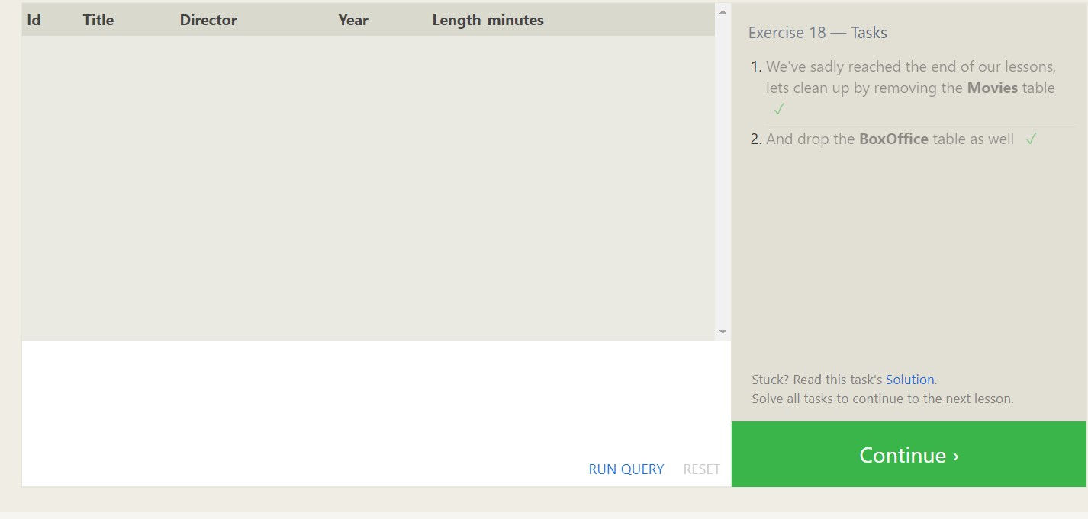

1.drop table movies;

2. drop table boxoffice;

